**Exercises in JavaScript**

**Date:04.02.2023**

1. **JavaScript getElementById() method example**

**HTML:**

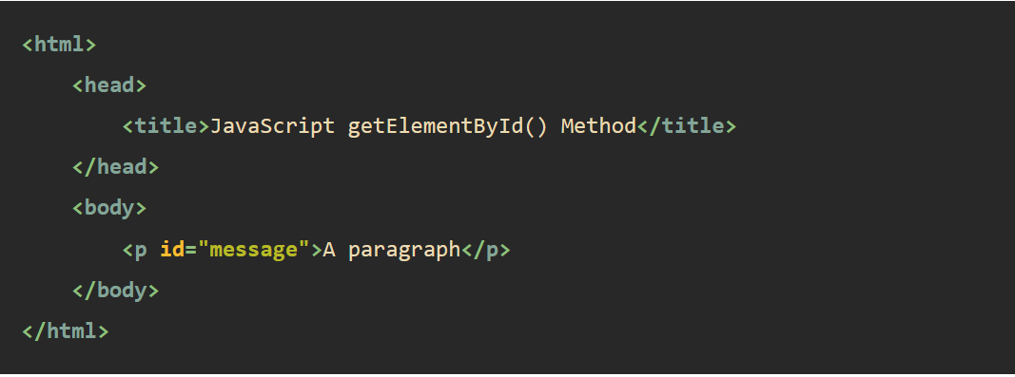

**Javascript:**

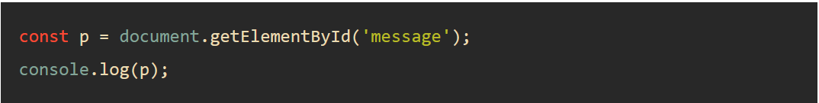

1. **JavaScript getElementsByName**

**HTML:**

1. <!DOCTYPE html>
2. <html>
3. <head>
4. <meta charset="utf-8" />
5. <title>JavaScript getElementsByName Demo</title>
6. </head>
7. <body>
8. <p>Please rate the service:</p>
9. <p>
10. <label for="very-poor">
11. <input type="radio" name="rate" value="Very poor" id="very-poor" /> Very
12. poor
13. </label>
14. <label for="poor">
15. <input type="radio" name="rate" value="Poor" id="poor" /> Poor
16. </label>
17. <label for="ok">
18. <input type="radio" name="rate" value="OK" id="ok" /> OK
19. </label>
20. <label for="good">
21. <input type="radio" name="rate" value="Good" /> Good
22. </label>
23. <label for="very-good">
24. <input type="radio" name="rate" value="Very Good" id="very-good" /> Very
25. Good
26. </label>
27. </p>
28. <p>
29. <button id="btnRate">Submit</button>
30. </p>
31. <p id="output"></p>
32. <script src="./main.js"></script>
33. </body>
34. </html>

**Javascript:**

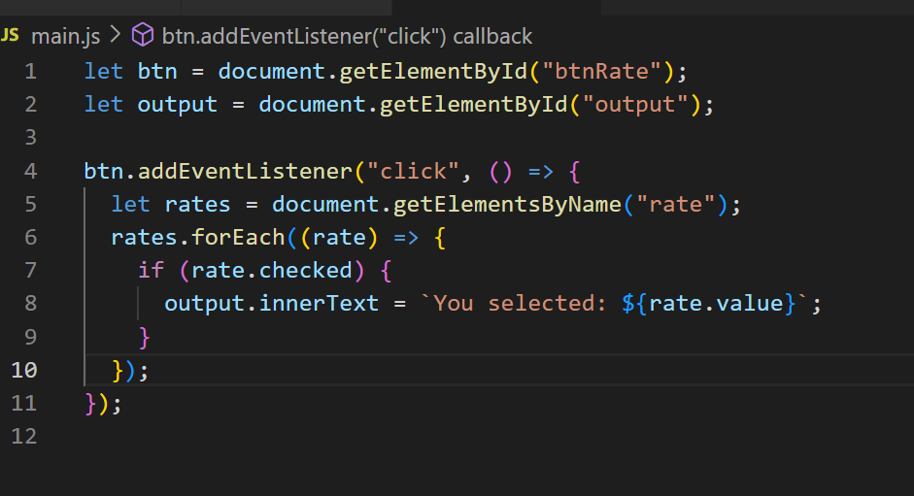

**3.** **JavaScript getElementsByClassName() method examples**

**HTML:**

<!DOCTYPE html>

<html lang="en">

  <head>

    <meta charset="UTF-8" />

    <meta name="viewport" content="width=device-width, initial-scale=1.0" />

    <title>JavaScript getElementsByClassName</title>

  </head>

  <body>

    <header>

      <nav>

      <h1>getElementsByClassName</h1>

    </header>

    <section>

      <article>

        <h2 class="secondary">Example 1</h2>

      </article>

      <article>

        <h2 class="secondary">Example 2</h2>

      </article>

    </section>

    <p class="output"></p>

    <script src="./main.js"></script>

  </body>

</html>

**Javascript:**

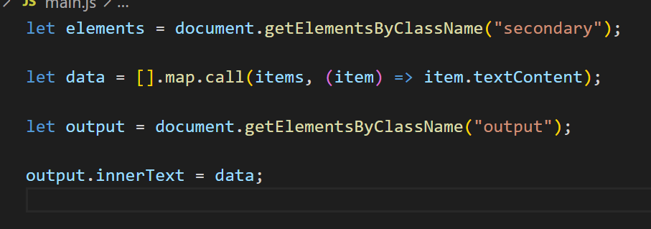

**4.** **HTML DOM innerHTML**

**HTML & Javascript**

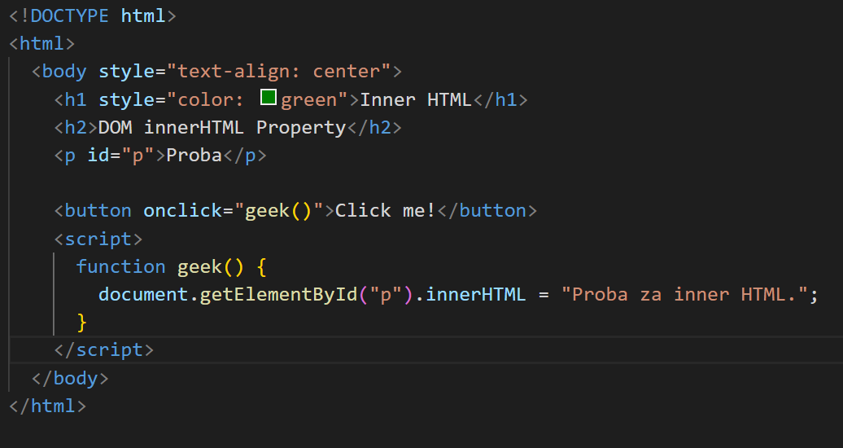

**Output:**

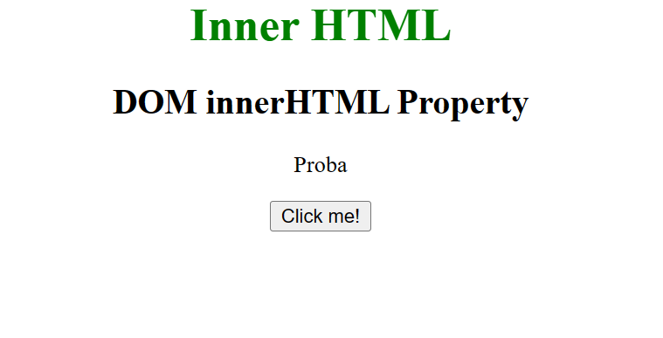

**5.** **How To Change CSS With JavaScript**

**-Change CSS inline properties with JavaScript (Javascript CSS and HTML together)**

<!DOCTYPE html>

<html lang="en">

  <head>

    <meta charset="UTF-8" />

    <meta http-equiv="X-UA-Compatible" content="IE=edge" />

    <meta name="viewport" content="width=device-width, initial-scale=1.0" />

    <title>Document</title>

    <style>

      .demo {

        padding: 10px 20px;

        margin-bottom: 20px;

        font-size: 3em;

      }

      button {

        padding: 10px 20px;

        font-size: 1.2em;

      }

      body {

        font-family: arial;

        padding: 1em;

      }

    </style>

  </head>

  <body>

    <div class="demo">Hello</div>

    <button class="add">Change CSS style</button>

  </body>

  <script>

    const button = document.querySelector("button");

    button.addEventListener("click", () => {

      const element = document.querySelector(".demo");

      element.style.backgroundColor = "red";

    });

  </script>

</html>

**Output**

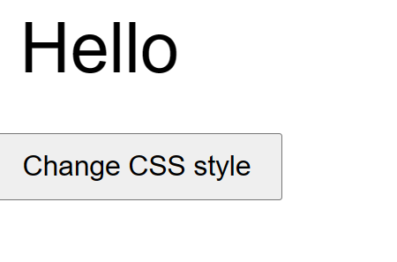

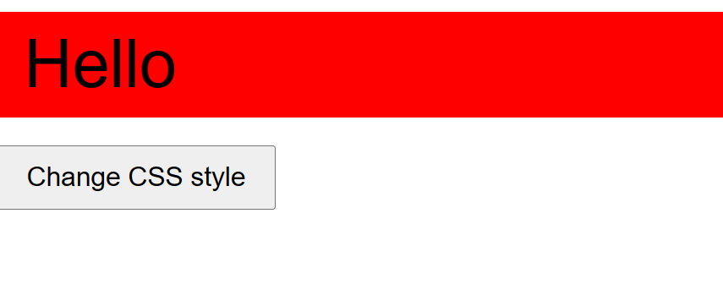

* **Set Multiple CSS Styles At The Same**

**(Javascript CSS and HTML together)**

<!DOCTYPE html>

<html lang="en">

  <head>

    <meta charset="UTF-8" />

    <meta http-equiv="X-UA-Compatible" content="IE=edge" />

    <meta name="viewport" content="width=device-width, initial-scale=1.0" />

    <title>Document</title>

    <style>

      .demo {

        padding: 10px 20px;

        margin-bottom: 20px;

        font-size: 3em;

      }

      .element {

        color: blue;

      }

      button {

        padding: 10px 20px;

        font-size: 1.2em;

      }

      body {

        font-family: arial;

        padding: 1em;

        font-weight: bold;

      }

    </style>

  </head>

  <body>

    <div class="demo" style="color: red">Hello</div>

    <button class="add">Change CSS style</button>

    <script>

      const button = document.querySelector("button");

      button.addEventListener("click", changeMultipleCSS);

      function changeMultipleCSS(e) {

        // Defining all our CSS styles

        const myStyles = `

    display: block;

    width: 80%;

    background-color: red;

    border: 2px;

    font-size: 5em;

    color: white;

    margin: 20px;

    padding-left: 10px;

    padding-bottom: 10px;

    border: 2px solid black;

  `;

        const element = document.querySelector(".demo");

        element.style.cssText = myStyles;

      }

    </script>

  </body>

</html>

**OutPut**

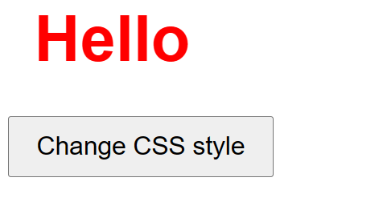

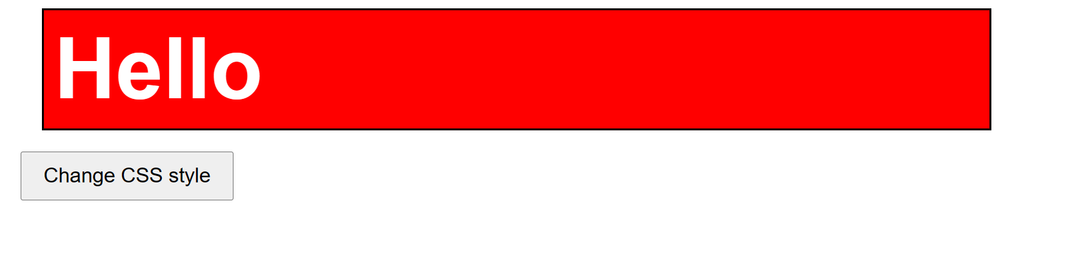

**-Change CSS class in JavaScript**

<!DOCTYPE html>

<html lang="en">

  <head>

    <meta charset="UTF-8" />

    <meta http-equiv="X-UA-Compatible" content="IE=edge" />

    <meta name="viewport" content="width=device-width, initial-scale=1.0" />

    <title>Document</title>

  </head>

  <style>

    .demo {

      padding: 10px 20px;

      margin-bottom: 20px;

    }

    .new-class {

      background: red;

    }

    button {

      padding: 10px 20px;

      font-size: 1.2em;

    }

    body {

      font-family: arial;

      padding: 1em;

    }

  </style>

  <body>

    <div class="demo">Hello</div>

    <button class="add">Add Class</button>

    <button class="remove">Remove Class</button>

    <button class="toggle">Toggle Class</button>

    <script>

      const buttonAdd = document.querySelector(".add");

      buttonAdd.addEventListener("click", addClass);

      const buttonRemove = document.querySelector(".remove");

      buttonRemove.addEventListener("click", removeClass);

      const buttonToggle = document.querySelector(".toggle");

      buttonToggle.addEventListener("click", toggleClass);

      function addClass() {

        const element = document.querySelector(".demo");

        element.classList.add("new-class");

      }

      function removeClass() {

        const element = document.querySelector(".demo");

        element.classList.remove("new-class");

      }

      function toggleClass() {

        const element = document.querySelector(".demo");

        element.classList.toggle("new-class");

      }

    </script>

  </body>

</html>

**OutPut:**

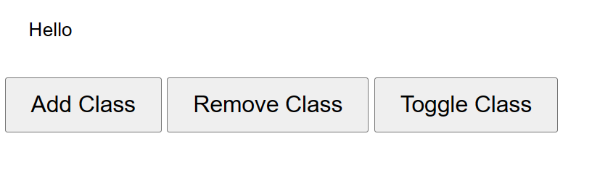

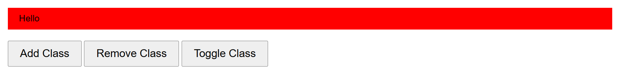

**Add Class**

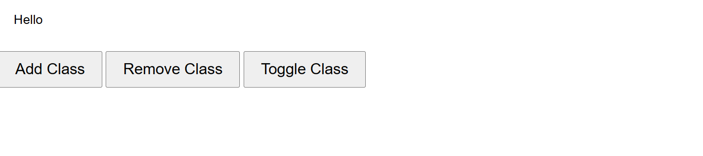

**Remove Class**

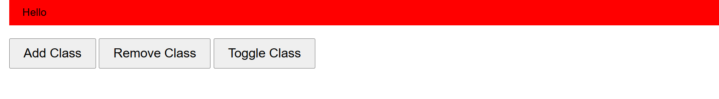

**Toggle Class**